**Abstract**

This web application is to be conceived in its current form as a dynamic site requiring constant updates both from the seekers as well as the companies. The objective of the project is to enable jobseekers to place their resumes and find appropriate jobs while companies to publish their vacancies and find good candidates. It enables jobseekers to post their resume, search for jobs, view personal job listings. It will provide various companies to place their vacancy profile on the site and also have an option to search candidate resumes.

**Project Modules**

• **Job seeker module**:

After registration job seeker can perform following actions such as search jobs, apply online for desire job and upload resume. Anyone can view job details but to apply job user need to be registered to the system by entering name, email-id, password and his resume.

• **Job provider Module (company)**:

In the job provider module can easily manage all job-related information’s such as add/edit new job vacancies, edit/deactivate posted jobs .

• **Administrator module**:

Administrator can manage website.Manage jobseeker section and company.Like activate/deactivate/ jobseekers, Admin user can activate/deactivate company information.

.

UML DIAGRAM

**Class Diagram**

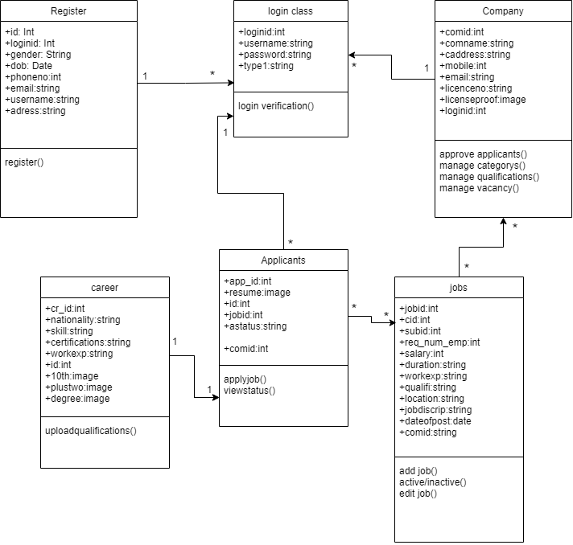

**Usecase Diagram**

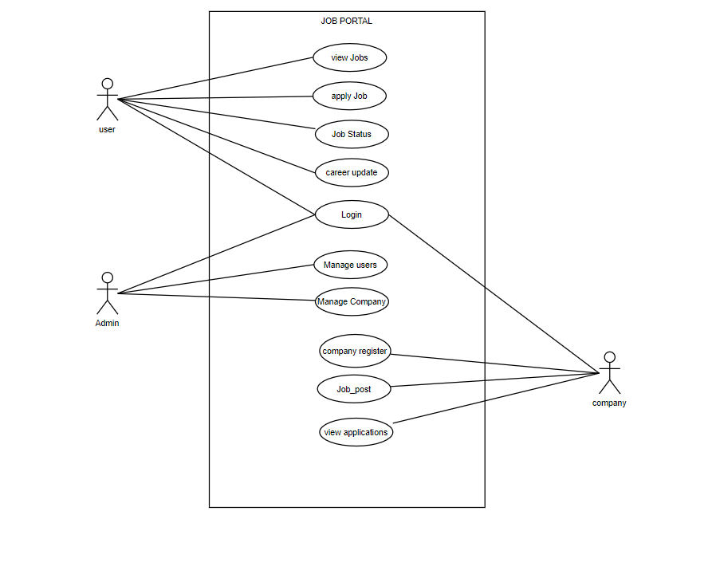

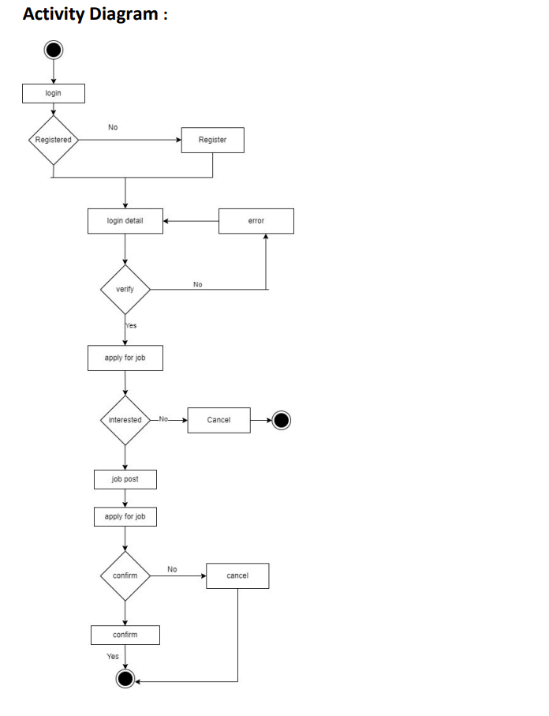

**State Diagram :** 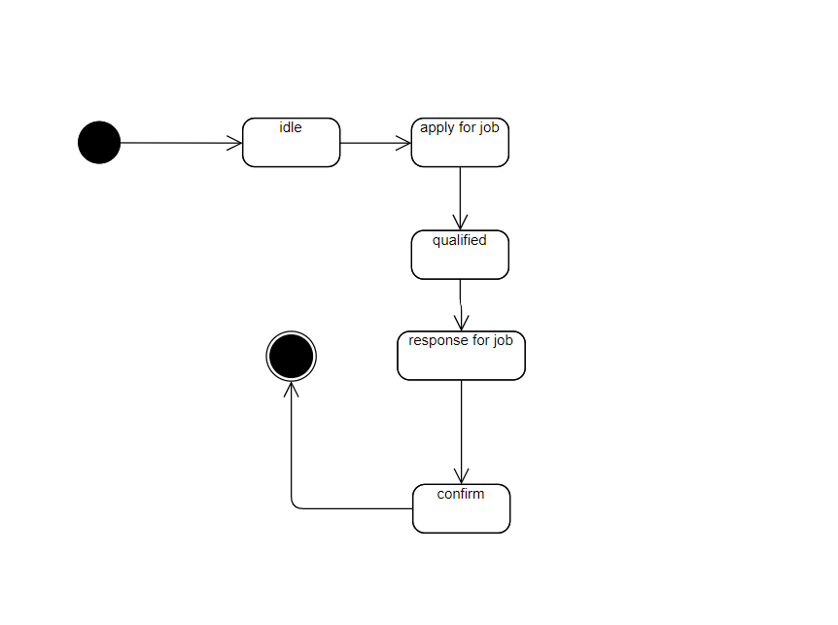

**Object Diagram :** 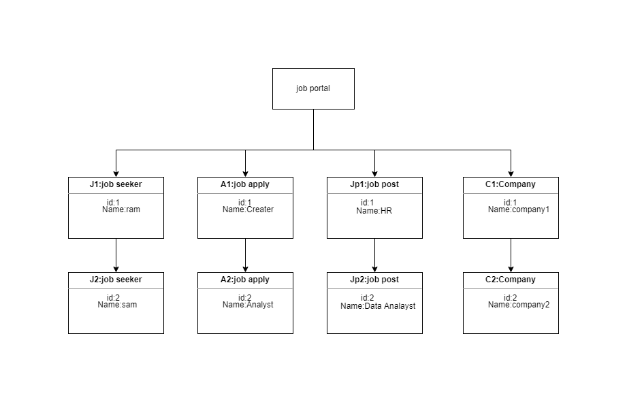

**Sequence Diagram for company**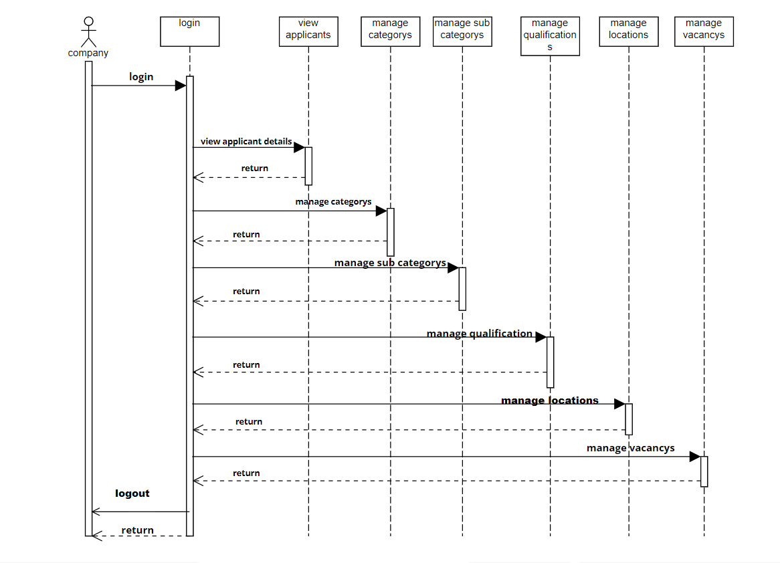

**Sequence Diagram for job seeker**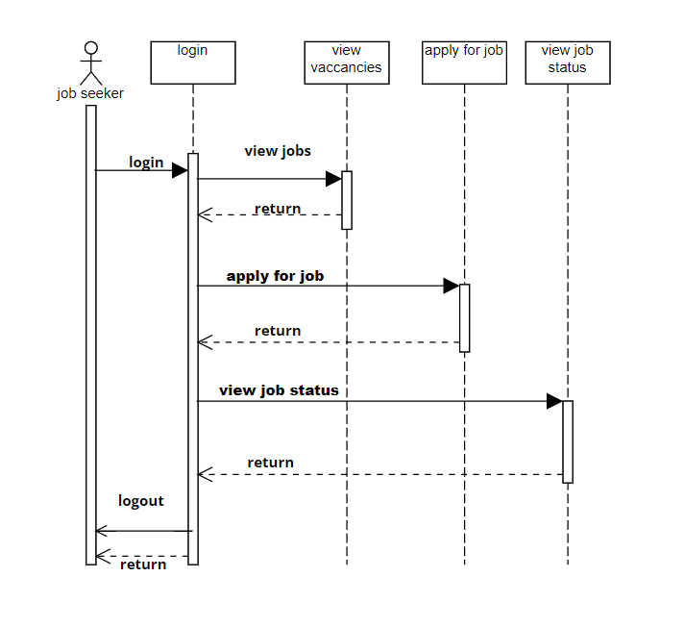

**Componet Daigram :**



**Deployment Daigram :**

